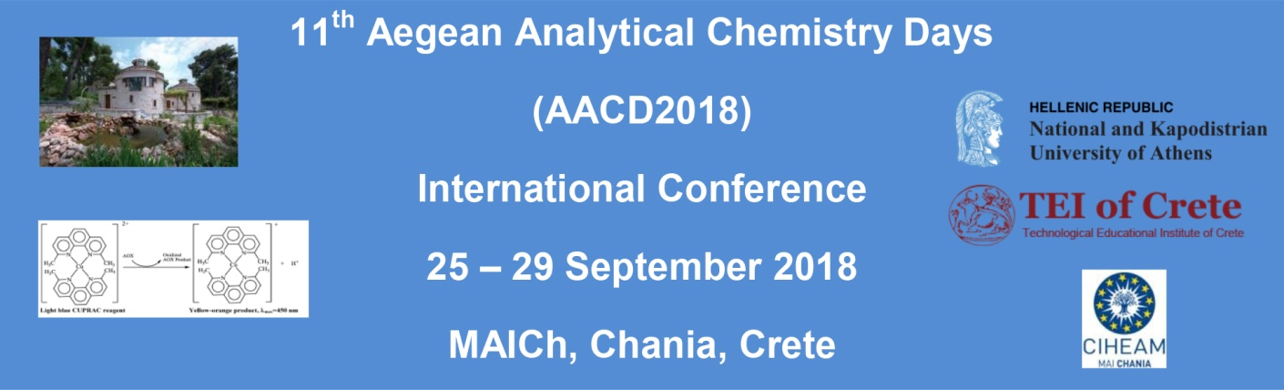
PRE-REGISTRATION FORM
For POST-CONFERENCE EXCURSION
To KNOSSOS and HERAKLEIO
(Sunday, 30th of September)

Dear Participant
If you are interested to participate to the Post-Conference Excursion to Knossos and Herakleio on Sunday 30th of September, please fill your details and return to the Conference Secretariat.
Please note that the minimum number of participants for the excursion is 30 and payment will be made during registration.

Conference Secretariat:
Attn. Ms Athina Gkika
National and Kapodistrian University of Athens
Department of Chemistry
Laboratory of Analytical Chemistry
Athens, Greece
Fax: +302107274750
Email: aacd2018@chem.uoa.gr
Website: http://www.chem.uoa.gr/aacd2018

AACD2018 PARTICIPANT
Title :
First Name: |  | Family Name:
Email: |  | Mobile:

ACCOMPANYING PERSONS
1. | Mr/Ms | First Name: |  | Family Name:
2. | Mr/Ms | First Name: |  | Family Name:

Please return by e-mail to aacd2018@chem.uoa.gr

